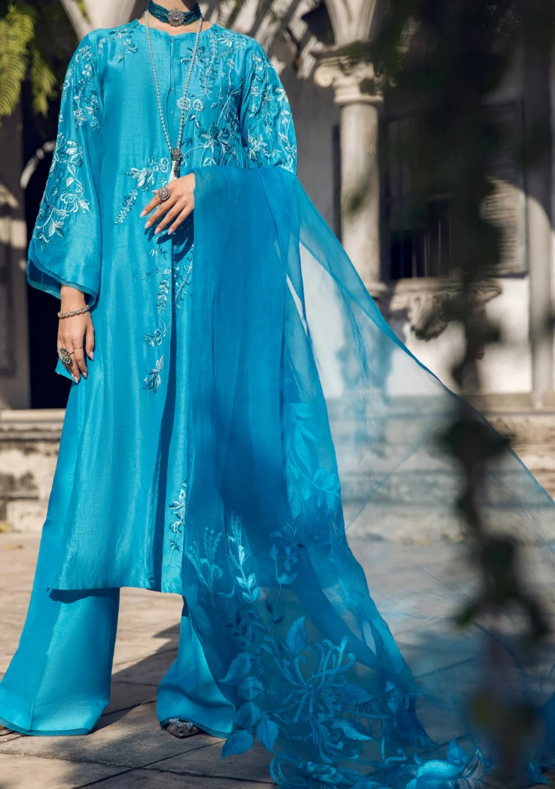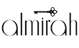

# BLUE LAWN 3 PIECE STITCHED - ALP-3PS-1733

Regular priceRs.8,650.00

**ADDITIONAL INFO**

|  |  |
| --- | --- |
| **Color** | Blue |
| **Pieces** | 3 Pieces |
| **Fit Type** | — |
| **Fabric** | Lawn, |
| **Season** | Summer Collection |
| **Disclaimer** | Due to the photographic lighting & different screen calibrations, the colors of the original product may slightly vary from the picture. |